**Installation/Maintenance Guide**

To be able to install the application, follow the provided steps:

1. Use a computer running macOS High Sierra or above.
2. The following are the recommended minimum hardware specifications:
   1. Processor: 2.5GHz
   2. RAM: 8GB
   3. Graphics: NVIDIA GeForce 320M

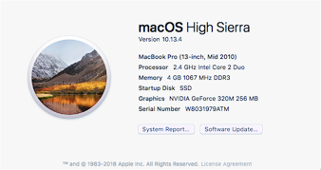

1. Install XCode 9 or above.
   1. In your computer open the App Store
   2. Inside the App Store, search for “XCode”
   3. Click on the “Get” button by the XCode icon. The button will turn green and change the text to say “Install App”. Click on the button again to start to install XCode into your computer
   4. Once the application is installed, you can go to your Applications folder in your computer to find the XCode launcher. Click on the launcher to start the application and check for any updates.

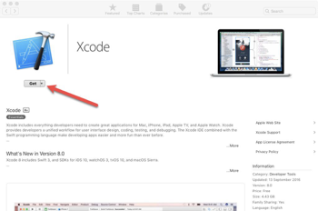

1. Download a copy of the project files.
   1. Visit <https://github.com/FIU-SCIS-Senior-Projects/Citizen-Scientist-Project-App-1.0>
   2. Inside the master branch, click on the green button by the right side of your monitor that reads “Clone or download”.
   3. A pop-up screen should come up, inside this pop-up screen click on the “Download ZIP” text. This will begin downloading a zip file.
   4. After the zip file is finished installing you can extract it and will be presented with a folder containing all the project files.

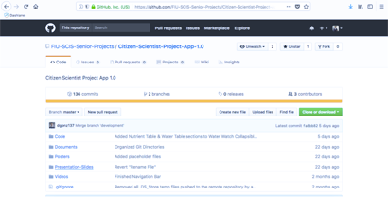

1. Open application.
   1. Open the project folder and inside you will see five other folders. Click on the “Code” folder to start finding the application’s source files.
   2. Inside the “Code” folder you will find copies of the Installation Guide, User Manual, a README file and another folder labeled “iOS Application”. Click on the “iOS Application” folder.
   3. From here, click on the “Citizen Scientist Project” folder
   4. Finally, click on the “Citizen-Scientist-Project.xcodeproj” file to open the application inside of XCode.

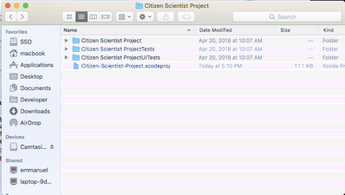

1. Run application
   1. On the top left of the XCode environment you will see a button with an iOS device icon or some text saying “Generic iOS Device”. Clicking this button will reveal a pop-up screen with more options in which you can run the application (including your personal phone).
   2. Inside of XCode, go to Citizen-Scientist-Project -> General. In there you will find various different sections, in the middle view. From these go into the “Signing” section and click on the “Team:” options. To sign the XCode environment and be able to run the application, make sure to select your name here.
   3. After you have signed the application and picked the device you wish to run the application in, you can click on the Run button in the top left of the XCode environment to install and run your application.

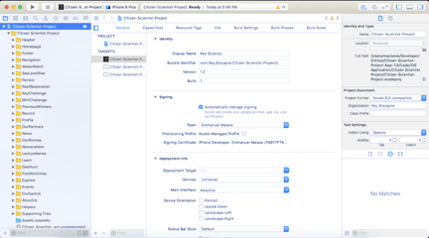

In future iterations, users will be able to download the application straight into their personal phones from the iPhone App Store.

To get a hands-on look at the installation or maintenance process feel free to look at our Installation/Maintenance video:

https://www.youtube.com/watch?v=__ZbQWTwP04&list=PLG3lylzOg8FjTwi6b5GqSi9-U2yx3bqOk&index=3